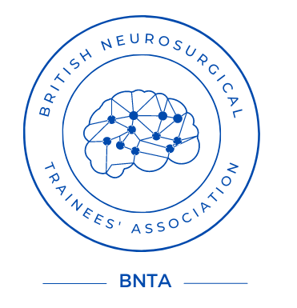

BNTA Extended travel Award Application 2024

Please return the completed form to the BNTA Treasurer at a.ali20@nhs.net by 5pm on Sunday 29th September 2024

Personal Details:

Name:

Address:

Email:

Telephone:

Current level of training:

FRCS(SN): Full FRCS / FRCS Part I / Neither [delete as appropriate]

Workplace/Deanery:

Training number:

Fellowship/Travel details:

Proposed Fellowship/Travel:

Subspecialty:

Start Date:

End Date:

Location:

Convenor / Supervisor:

Alternative sources of funding sought:

Please outline how the proposed fellowship/travel will benefit your professional development and sub-specialty training, and to what use the BNTA travel award funding would be put (max 400 words):

