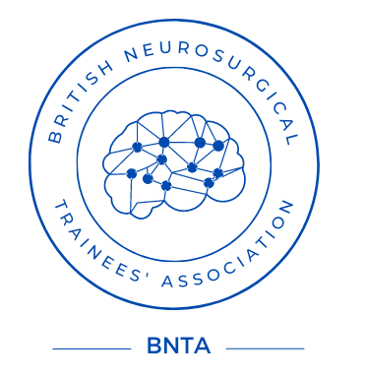

BNTA Extended travel Award Application 2025

Please return the completed form to the by 5pm on 2nd February 2026 via the BNTA website at www.e1v1m1.com/funding/

Personal Details: To be anonymised prior to scoring

Name:

Email:

Telephone:

Training Details: Visible to scoring committee

FRCS(SN): Full FRCS / FRCS Part I / Neither [delete as appropriate]

Workplace/Deanery:

Are you a trainee: Yes No [delete as appropriate]

National Training Number if applicable:

Fellowship/Travel details:

Proposed Fellowship/Travel:

Subspecialty:

Start Date:

End Date:

Location:

Named Host/s:

Alternative sources of funding sought:

Please outline your career ambitions, details and rationale for the trip, how the trip will benefit your personal development and how it may benefit UK neurosurgery. Please include a summary of the main costs associated with the trip, including planned funding, and how this award would be used (max 400 words):

