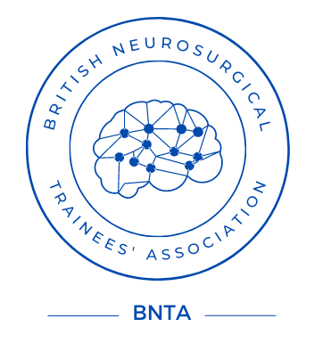
BNTA short travel award application 2025

Please return the completed form to the by 5pm on 2nd February 2026 via the BNTA website at www.e1v1m1.com/funding/

Personal Details: To be anonymised prior to scoring

Name:

Email:

Telephone:

Training Details: Visible to scoring committee

Current level of training:

Workplace/Deanery:

Are you a trainee: Yes No [delete as appropriate]

National Training Number if applicable:

Trip details: Visible to scoring committee

Start Date:

End Date:
Note: duration of travel should not exceed one-month

Leave obtained (i.e. Study leave, annual leave, OOP):

Location (Unit and Country):

Named Host/s:

Alternative sources of funding sought:

Please outline your career ambitions, details and rationale for the trip, how the trip will benefit your personal development and how it may benefit UK neurosurgery. Please include a summary of the main costs associated with the trip, including planned funding, and how this award would be used (max 400 words):

